**Pinout for Serial Ports and Loopback Test**

Publish Date: Feb 09, 2018 | 2 Ratings | **3.00** out of 5 | [Print](javascript:window.print())

**Overview**

This article provides pinout information for serial ports. It will also tell you which pins to connect for a loop back test.

**1. Introduction**

RS-232 is the single ended serial protocol and RS-485 and RS-422 are differential serial protocol. The pinout for RS-232, RS-422 and RS-485 is shown below figure.

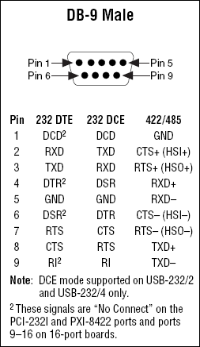

A loopback test is a test in which a signal in sent from a communications device and returned (looped back) to it as a way to determine whether the device is working right. The figures below will show you what pins you need to connect to perform loopback test on RS-232 and RS-422/RS-485 respectively.

**RS-232**

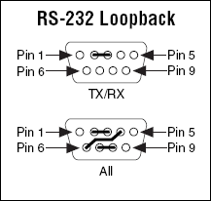

**RS-422 and RS-485**

